* 1. Done in python
  2. Done in Python

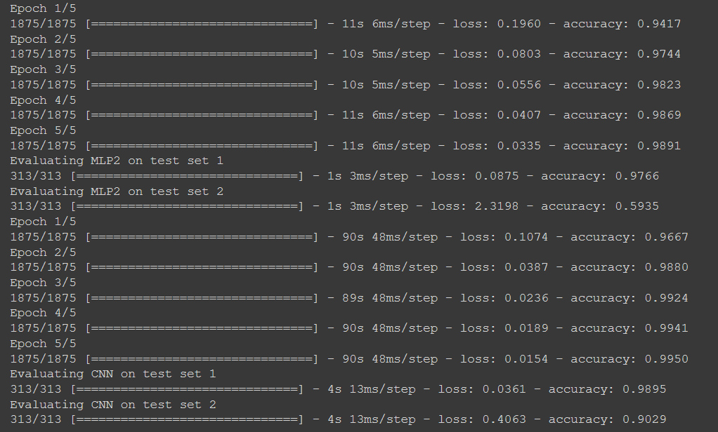

* 1. For test set 1, the accuracy was 0.9766 while for test set 2, the accuracy was 0.5935
  2. For test set 1, the accuracy was 0.9895 while for test set 2, the accuracy was 0.9029
  3. For me, the CNN proved to have a better accuracy on both tests in comparison to the Feedforward network. This is because for a CNN, we are using fewer parameters and have sparser connections between nodes which leads to our network being more efficient at classifying the images than a feedforward network which will need a lot more calculations due to the larger number of parameters it will take.

1. Here we use Bayes Rules to get the Posterior Model Probability.

Recall Bayes Rules is

P(θ1) = P(θ2) and P(θ3)= 3 P(θ1).

Therefore: 5 P(θ1)=1

P(θ1)= P(θ2) =0.2 and P(θ3)=0.6

P(D) = = + +

= 0.2\* 0.00084 + 0.2\*0.00105 = 0.6\*0.00007

= 0.00042

Therefore, the Posterior Probabilities for each model are

p(θ1|D) = = 0.2\* 0.00084 / 0.00042 = 0.4

p(θ2|D) = = 0.2\* 0.00105 / 0.00042 = 0.5

p(θ3| D ) = = 0.6\* 0.00007 / 0.00042 = 0.1

1. You would be better of selling as we first take the argmax θ  to get our selected θwhich, based off the previous question, is θ2 . Given theta two, the prediction we get is p(yt+1 | yt , θ2 ) = .4 . As 0.4<0.5, it would be better to sell.
2. Based on the posterior predictive distribution, we would be better off buying as to get the posterior predictive distribution, we first do the calculation $\sum_{θ}{p\left(\left.θ\right|D\right)p\left(\left.y_{t+1}\right|y_{t},θ\right)}$ = 0.75\*0.4+0.5\*0.5+0.1\*0.6= 0.56. As 0.56>0.5, we would be better of buying.